|  |
| --- |
|  |
| **Lab-07_OOP** |
| MUSAFAR  021-21-0012  BS (CS) – II , Section - A |

|  |
| --- |
|  |

**Exercise 1 (Packages):**

1. Create three packages, think of them yourself
2. Put two different classes in each package
3. Import all three of these packages in class named PackagePractice, you will have access to 6 classes
4. Call methods of these 6 classes and use them in PackagePractice

**Code:**

**CLASSES IN PACKAGE 1**

package package1;

public class Sum{

int a = 10;

int b = 20;

public void sum(){

System.out.println("Sum of two numbers: " + (a+b));

}

public static void main(String []arg){

Sum sum1 = new Sum();

sum1.sum();

}

}

package package1;

public class Subtract{

int a = 10;

int b = 20;

public void subtract(){

System.out.println("Subtraction of two numbers: " + (a-b));

}

public static void main(String []arg){

Subtract subtract1 = new Subtract();

subtract1.subtract();

}

}

**CLASSES IN PACKAGE 2**

package package2;

public class Multiplication{

int a = 10;

int b = 20;

public void multiply(){

System.out.println("Multiplication of two numbers: " + (a*b));

}

public static void main(String []arg){

Multiplication m = new Multiplication();

m.multiply();

}

}

package package2;

public class Division{

double a = 10;

double b = 20;

public void division(){

System.out.println("Division of two numbers: " + (a/b));

}

public static void main(String []arg){

Division d = new Division();

d.division();

}

}

**CLASSES IN PACKAGE 3**

package package3;

public class Percentage{

double a = 10;

double b = 20;

public void percentage(){

System.out.println("Percentage of two numbers: " + ((a/b)*100));

}

public static void main(String []arg){

Percentage p = new Percentage();

p.percentage();

}

}

package package3;

public class Modulus{

int a = 10;

int b = 20;

public void modulus(){

System.out.println("Modulus of two numbers: " + (a%b));

}

public static void main(String []arg){

Modulus mod = new Modulus();

mod.modulus();

}

}

**PACAKGE PRACTICE CLASS**

import package1.*;

import package2.*;

import package3.*;

class PackagePractice{

public static void main(String []arg){

Sum s = new Sum();

Subtract sb = new Subtract();

Multiplication m = new Multiplication();

Division d = new Division();

Percentage p = new Percentage();

Modulus mod = new Modulus();

s.sum();

sb.subtract();

m.multiply();

d.division();

p.percentage();

mod.modulus();

}

}

**Output:**

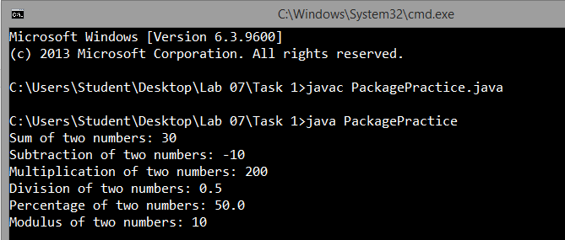

**Exercise 2 (Interfaces):**

1. What is wrong with the following interface?

public interface SomethingIsWrong {

void aMethod(int aValue){

System.out.println("Hi Mom");

}

}

1. Fix the interface in question 1.
2. Is the following interface valid?

public interface Marker {

}

**Answer of part 1:**

As we know that in interfaces we can only define abstract methods but in java 8 and in java 9 allow us to define default, static and private methods in interfaces And we see in code that the method is default but it has a body as well that’s the error in the code of part 1 because in interfaces you cannot define the body of method. Interfaces are auto public so that’s why you can’t write public with interfaces.

**Answer of part 2:**

**Code:**

interface SomethingIsWrong {

void aMethod(int aValue);

}

class InterfaceTest implements SomethingIsWrong{

public void aMethod(int aValue){

System.out.println("Value passed in interface method whose body defines where it implements: " + aValue);

}

public static void main(String arg[]){

InterfaceTest obj = new InterfaceTest();

obj.aMethod(23);

}

}

**Output:**

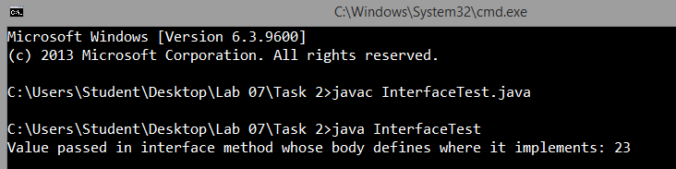

**Answer of part 3:**

No, it is not valid you can’t write public access modifier with interfaces because interfaces are auto public you not need to write it.

**Exercise 3 (Interfaces):**

1. Create the Animal interface.
2. Declare abstract method legs.
3. Declare an abstract method eat.
4. Create the Spider, Caterpillar and Cat class that implements animal interface.
5. The Spider class extends the Animal class.
6. Implement the eat and legs method

**Code:**

interface Animal{

void legs(int nbLegs);

void eat(String foodName);

}

class Spider implements Animal{

public void legs(int nbLegs){

System.out.println("Spider has " + nbLegs + " legs");

}

public void eat(String foodName){

System.out.println("Spider is eating "+ foodName);

}

}

class Caterpillar implements Animal{

public void legs(int nbLegs){

System.out.println("Caterpillar has " + nbLegs + " legs");

}

public void eat(String foodName){

System.out.println("Caterpillar is eating "+ foodName);

}

}

class Cat implements Animal{

public void legs(int nbLegs){

System.out.println("Cat has " + nbLegs + " legs");

}

public void eat(String foodName){

System.out.println("Cat is eating "+ foodName);

}

}

class AnimalTest{

public static void main(String []arg){

Spider s = new Spider();

s.legs(6);

s.eat("insects");

Caterpillar c1 = new Caterpillar();

c1.legs(6);

c1.eat("Grass");

Cat c2 = new Cat();

c2.legs(4);

c2.eat("meal");

}

}

**Output:**

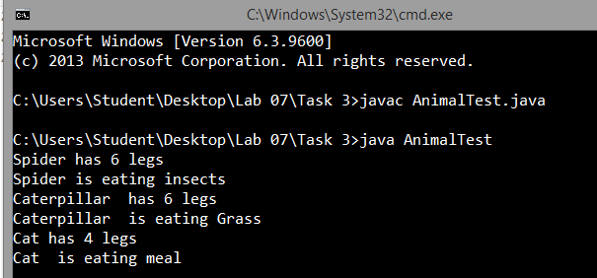

**Exercise 4 (Abstract class):**

We have to calculate the percentage of marks obtained in three subjects (each out of 100) by student A and in four subjects (each out of 100) by student B. Create an abstract class 'Marks' with an abstract method 'getPercentage'. It is inherited by two other classes 'A' and 'B' each having a method with the same name which returns the percentage of the students. The constructor of student A takes the marks in three subjects as its parameters and the marks in four subjects as its parameters for student B. Create an object for each of the two classes and print the percentage of marks for both the students.

**Code:**

abstract class Marks{

abstract double getPercentage();

}

class A extends Marks{

double marks1, marks2, marks3;

A(double marks1, double marks2, double marks3){

this.marks1 = marks1;

this.marks2 = marks2;

this.marks3 = marks3;

}

double getMarks1(){

return marks1;

}

double getMarks2(){

return marks2;

}

double getMarks3(){

return marks3;

}

double getPercentage(){

double percentage;

percentage = ((getMarks1() + getMarks2() + getMarks3())/300)*100;

return percentage;

}

}

class B extends Marks{

double marks1, marks2, marks3, marks4;

B(double marks1, double marks2, double marks3, double marks4){

this.marks1 = marks1;

this.marks2 = marks2;

this.marks3 = marks3;

this.marks4 = marks4;

}

double getMarks1(){

return marks1;

}

double getMarks2(){

return marks2;

}

double getMarks3(){

return marks3;

}

double getMarks4(){

return marks4;

}

double getPercentage(){

double percentage;

percentage = ((getMarks1() + getMarks2() + getMarks3() + getMarks4())/400)*100;

return percentage;

}

}

class MarksTest{

public static void main(String []arg){

A std1 = new A(78, 45, 89);

B std2 = new B(98, 78, 65, 60);

System.out.println("Percentage of student 1 in 3 subjects: " + std1.getPercentage());

System.out.println("Percentage of student 2 in 4 subjects: " + std2.getPercentage());

}

}

**Output:**

